




Transforming Raw Sales Data into Actionable
Insights

Project Domain
Excel / Power BI

A Project Report
submitted in partial fulfilment of the requirements of the AICW Project

by:



Student Email
harikakanapuram2006@gmail.com
Student Name
Khanapuram Harika

Guide
Uma maheshwari

Institution:
Rishi UBR Women’s College
Year - 2026
ACKNOWLEDGEMENT

I would like to take this opportunity to express my deep sense of gratitude to all individuals who helped me directly or indirectly during this project work.
Firstly, I would like to thank my supervisor Laxmi Tulasi mam & Umamaheshwari mam, for being a great mentor and the best adviser I could have asked for. Their advice, encouragement, and constructive feedback served as a source of innovative ideas and inspiration, and were central to the successful completion of this project. The confidence shown in me was the biggest source of motivation throughout this journey.
I extend my sincere thanks to the Edunet Foundation, Microsoft, LinkedIn, and SAP for providing this fellowship opportunity, the learning resources, and the platform to develop and showcase AIskills.
I am also grateful to my institution, Rishi UBR Women’s College, for providing the necessary infrastructure and support throughout the project duration.
Finally, I thank my family and friends for their continuous encouragement and support.

ABSTRACT OF THE PROJECT

This project is part of the AICW (Artificial Intelligence in the Contemporary World) Fellowship Program, a collaborative initiative by Edunet Foundation in partnership with Microsoft, LinkedIn, and SAP. The fellowship is designed to equip students with practical, hands-on skills in Artificial Intelligence, Data Analytics, and Business Intelligence tools.
This project analyzes Global Superstore sales data using Excel and Power BI with Copilot assistance. The dataset required cleaning to remove duplicates, fix missing values, and correct formatting issues. After preprocessing, interactive dashboards were created to visualize revenue trends, product performance, and regional sales. Key insights revealed top-selling categories, profitable regions, and customer behavior patterns. Overall, the project demonstrates how data cleaning and visualization can turn raw data into actionable business intelligence.
TABLE OF CONTENTS

Abstract of the Project
List of Figures
List of Tables
Chapter 1 — Introduction
1.1 Problem Statement
1.2 Motivation
1.3 Objectives
1.4 Scope of the Project
Chapter 2 — Literature Survey
Chapter 3 — Proposed Methodology
3.1 System Design
3.2 Modules / Components Used
3.3 Data Flow Diagram (DFD)
3.4 Advantages
3.5 Requirement Specification
Chapter 4 — Implementation and Results
4.1 Data Cleaning Results
4.2 Visualization / Output Results
4.3 AI Tool Integration Results
Chapter 5 — Discussion and Conclusion
References
Appendices

LIST OF FIGURES

Figure No. | Figure Title / Description | Page No.
Figure 1 | [Raw / uncleaned dataset screenshot] | 12
Figure 2 | [Cleaned dataset or validation summary screenshot] | 13
Figure 3 | [Main dashboard / report / output screenshot] | 13
Figure 4 | [Additional chart or visualization screenshot] | 14
Figure 5 | [AI tool (Copilot / Chatbot) in use screenshot] | 15
Figure 6 | [DFD Level 0 — Context Diagram] | 10
Figure 7 | [DFD Level 1 — Detailed Process Flow] | 11

LIST OF TABLES

Table No. | Table Title / Description | Page No.
Table 1 | Hardware requirements | 11
Table 2 | Software requirements | 12
Table 3 | Raw dataset | 13
Table 4 | Cleaned and structured dataset | 14
Table 5 | Key findings / summary | 16,17

CHAPTER 1
Introduction
This chapter introduces the project undertaken as part of the AICW Fellowship Program. It outlines the background, the problem being addressed, the motivation behind this work, and the objectives and scope of the project. The fellowship projects span multiple domains including Data Analytics, Business Intelligence, Healthcare Analytics, Content Generation, and AI-assisted Reporting.
1.1 Problem Statement
- What is the main problem or challenge in your chosen domain?
- Organizations struggle with managing large volumes of unstructured data ,duplicate and incomplete sales data leading to inefficiencies in data retrieval and analysis.
- Why is this problem significant, and what is its real-world impact?
This problem is significant because it results in wasted time, increased operational costs, and missed opportunities for data-driven decision-making. Inaccurate or delayed insights can negatively affect business growth and competitiveness.
- Who is affected by this problem — what are the target users or organizations?
The primary users affected are data analysts, business managers, and IT departments within medium to large enterprises that rely on timely and accurate data for strategic planning.
- What are the limitations of existing approaches or tools currently available?
Current tools often lack advanced search capabilities, are not user-friendly, or cannot handle the scale and complexity of modern data environments. As a result, users face challenges in quickly finding relevant information and generating actionable insights.
1.2 Motivation

- Why is this project personally or professionally meaningful to you?
I am passionate about leveraging technology to solve complex problems and drive innovation. Working on AI and data analytics allows me to combine my interest in data-driven decision-making with the opportunity to make a tangible impact on organizations.
- What are the potential applications of this project in the real world?
AI and data analytics projects have wide-ranging applications, such as improving business operations, enhancing customer experiences, optimizing supply chains, and enabling predictive maintenance in industries like finance, healthcare, and retail​.

- What impact could this project have on the organization or domain?
By implementing advanced analytics and AI, organizations can automate routine tasks, uncover hidden patterns in data, and make faster, more accurate decisions. This can lead to increased efficiency, cost savings, and a stronger competitive advantage​.
- How does this project align with modern industry trends in AI and data analytics?
The integration of AI with data analytics is a major industry trend, enabling organizations to process vast amounts of data at unprecedented speed and scale. AI-driven analytics is transforming traditional business intelligence into a strategic asset, supporting real-time insights and personalized experiences for users​.
1.3 Objectives

- To collect and understand the structure of the dataset used in the project.
- To clean and preprocess raw data by removing duplicates, correcting formats, and handling missing values.
- To apply domain-specific analysis using Excel, Power BI, or Copilot.
- To build interactive dashboards or reports that clearly communicate insights.
- To leverage AI tools (Copilot) to automate or enhance the analysis and content generation process.
- The main objective of my project is to transform large and complex datasets into actionable insights that drive better decision-making and improve business outcomes.
1.4 Scope of the Project
- This project covers data from sales records.
- The tools used are limited to [Excel / Power BI / Copilot ] as assigned.
- The analysis focuses on data cleaning, visualization.
- The project is intended as a fellowship showcase and is not a production-level system.

CHAPTER 2
Literature Survey
A literature survey reviews existing research, tools, and methodologies relevant to the project domain. It helps identify gaps that the current project aims to address.
2.1 Existing Work and Research
- Review relevant literature or previous work in your project domain.
- Tools and Techniques used are microcoft Excel for data cleaning, filtering, sorting, removing duplicates and chart creation. Also Microsoft power BI offers advanced dashboarding capabilities, interactive visualization and data modeling features for business reporting. Microsoft copilot, for automate data cleaning, generate insights, and assist in report creation through prompt-based interactions.
- Existing solutions have certain limitations. Excel-based methods are often manual and time-consuming, making them less suitable for large datasets. Power BI provides strong visualization capabilities, it lacks real-time data integration and advanced predictive analytics in basic implementations.
- This project addresses these gaps by integrating data cleaning, analysis, and visualization in a unified workflow, supported by AI-assisted techniques for faster and more efficient insight generation.
2.2 Tools and Technologies Review
- Microsoft Excel — widely used for data cleaning, transformation, and basic visualization. Pivot tables, conditional formatting, and data validation are commonly used techniques.
- Microsoft Power BI — a business analytics tool that provides interactive visualizations and business intelligence capabilities with an interface simple enough for end users to create their own reports and dashboards.
- Microsoft Copilot (AI) — an AI assistant integrated into Microsoft 365 tools that helps automate tasks, generate summaries, and assist with data analysis using natural language prompts.
- AI Chatbots — generative AI tools used for content creation, marketing copy, report generation, and prompt-driven analysis.

2.3 Gaps Identified
- Most existing literature focuses on complex machine learning approaches; simpler, tool-based solutions for non-technical users are underexplored.
- There is limited documentation on integrating AI Copilot with Excel/Power BI for domain-specific analysis in the context of student projects.
- Prompt engineering best practices for business use cases are still evolving and lack standardized frameworks.
- Lack of Real-Time Data Integration and Data Quality & Consistency Issues.

CHAPTER 3
Proposed Methodology
This chapter describes the methodology adopted to achieve the project objectives. It covers the system design, modules used, data flow, advantages, and requirement specifications.
3.1 System Design
- Data Source / Input: CSV file with 51290 rows of sales transactions.
- Data Cleaning: removed duplicates, handled null values, corrected data types, standardized formats.
- Analysis / Processing: pivot tables, formulas, AI prompts, Power BI measures.
- Visualization / Output: interactive dashboard, summary report.
3.2 Modules / Components Used

- Module 1 — Data Ingestion: Loading the raw dataset into Excel / Power BI.
- Module 2 — Data Cleaning: Removing inconsistencies, duplicates, and null values.
- Module 3 — Data Analysis: Applying calculations, formulas, AI prompts, or DAX measures.
- Module 4 — Visualization / Report Generation: Building dashboards, charts, or AI-generated reports.
- Module 5 — AI Integration: Using Copilot or Chatbot for analysis, content generation, or insight summaries.
- Module 6 — Business Insights & Recommendation Engine : focuses on generating actionable insights and suggestions from the analyzed data.
3.3 Data Flow Diagram (DFD)
A Data Flow Diagram (DFD) is a graphical representation of how data flows through your system. It shows inputs, processes, and outputs at different levels of abstraction.
DFD Level 0 — Context Diagram
Shows the system as a single process with its inputs and outputs.
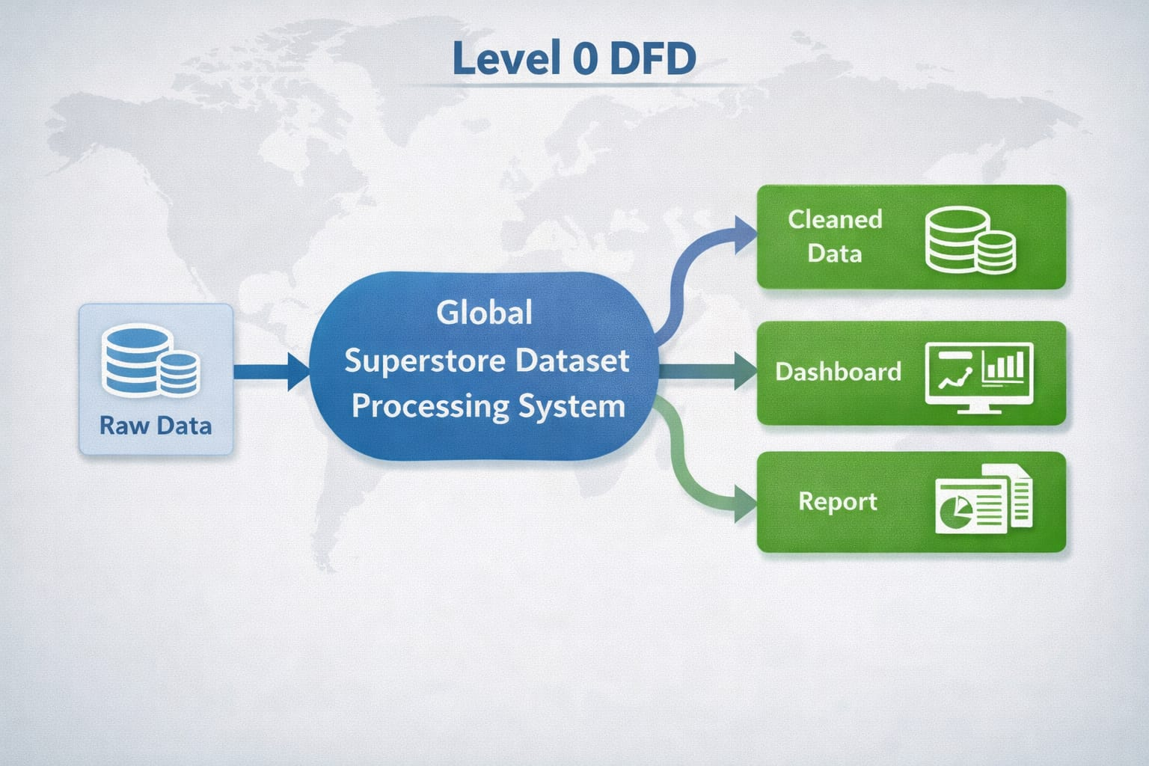
DFD Level 1 — Detailed Process Flow
Breaks down the main process into sub-processes.
- Sub-process 1: Data Loading and Validation
- Sub-process 2: Data Cleaning and Transformation
- Sub-process 3: Analysis and AI Processing
- Sub-process 4: Visualization and Report Generation
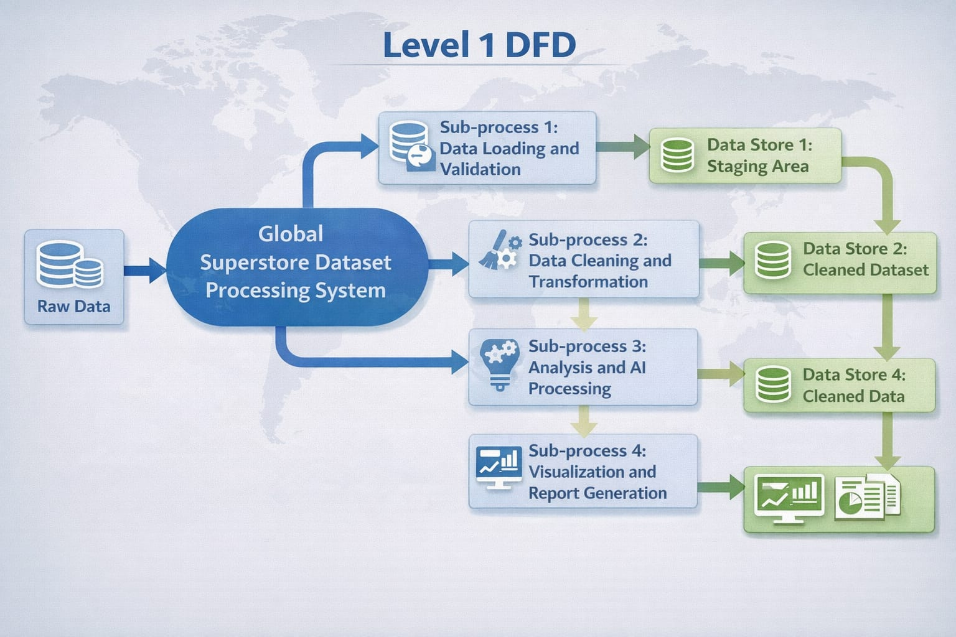
3.4 Advantages
- Automates repetitive data cleaning tasks, saving significant manual effort.
- Provides clear, visual insights that are easy to understand for non-technical stakeholders.
- Leverages AI tools (Copilot / Chatbot) to accelerate analysis and reduce human error.
- Scalable — the same methodology can be applied to larger datasets or different domains.
- Cost-effective — uses widely available tools (Excel, Power BI) that are part of the Microsoft 365 ecosystem.
- Supports business growth by highlighting profit opportunities and loss areas.
3.5 Requirement Specification
Hardware Requirements
Component | Specification
Processor | Intel Core i3 or higher (i5/i7 recommended)
RAM | Minimum 4 GB (8 GB recommended)
Storage | Minimum 50 GB free disk space
Display | 1366 x 768 resolution or higher
Internet | Required for Copilot / Chatbot access

Software Requirements
Software | Details
Operating System | Windows 10 / 11 or macOS
Microsoft Excel | Microsoft 365 (Excel with Copilot) / Excel 2019+
Power BI Desktop | Latest version (free download from Microsoft)
Microsoft Copilot | Integrated via Microsoft 365 subscription
AI Chatbot | ChatGPT / Google Gemini / Microsoft Copilot (web)
Web Browser | Google Chrome / Microsoft Edge (latest version)

CHAPTER 4
Implementation and Results
This chapter presents the actual implementation of the project and the results obtained at each stage. Screenshots of dashboards, cleaned datasets, or generated content should be inserted where indicated.
4.1 Data Cleaning Results

- Dataset source: downloaded from Kaggle.
- Original dataset size : rows and 24 columns
- Issues found: duplicates, null values, wrong data types.
- Cleaning steps applied: [Describe each step performed in Excel / Power BI / Chatbot prompts.]
- Cleaned dataset size: 51290 rows and 24 columns
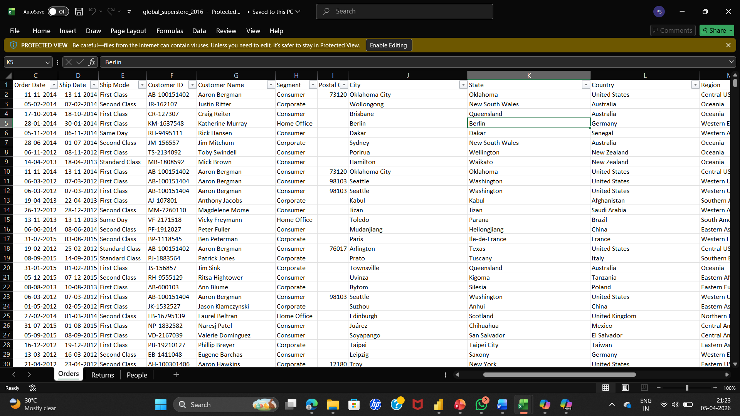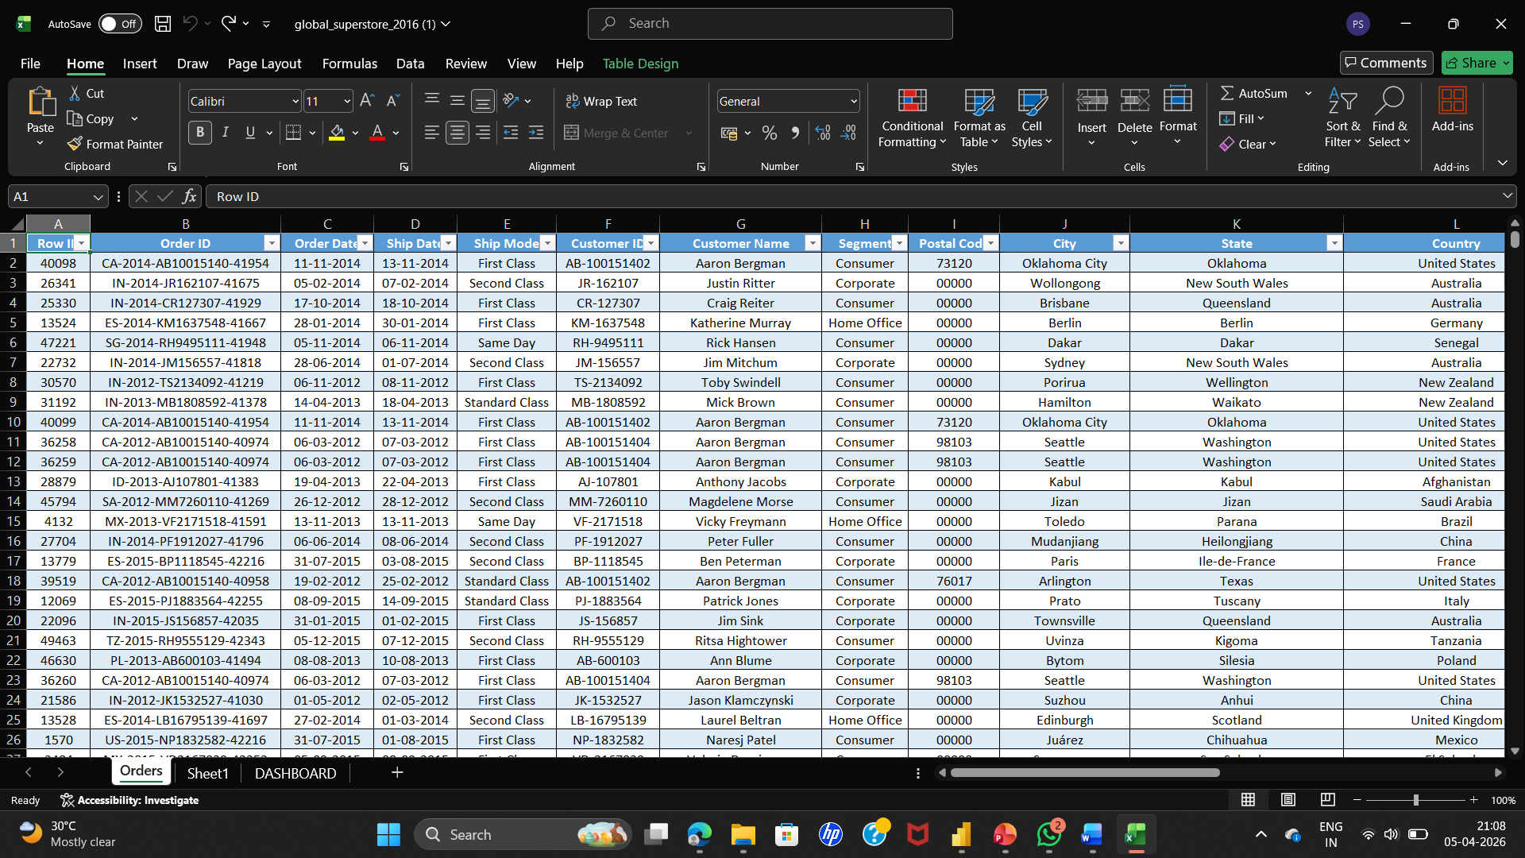

4.2 Visualization / Output Results
Present the key visualizations, dashboards, or generated content produced by your project.
- Dashboard / Chart 1: shows sales performance year wise.
- Dashboard / Chart 2: Regional Sales Performance Map.
- Dashboard / Chart 3: Top 10 Products by Profit Margin.
- Dashboard / chart 4 : it shows the comparision between sales and profit
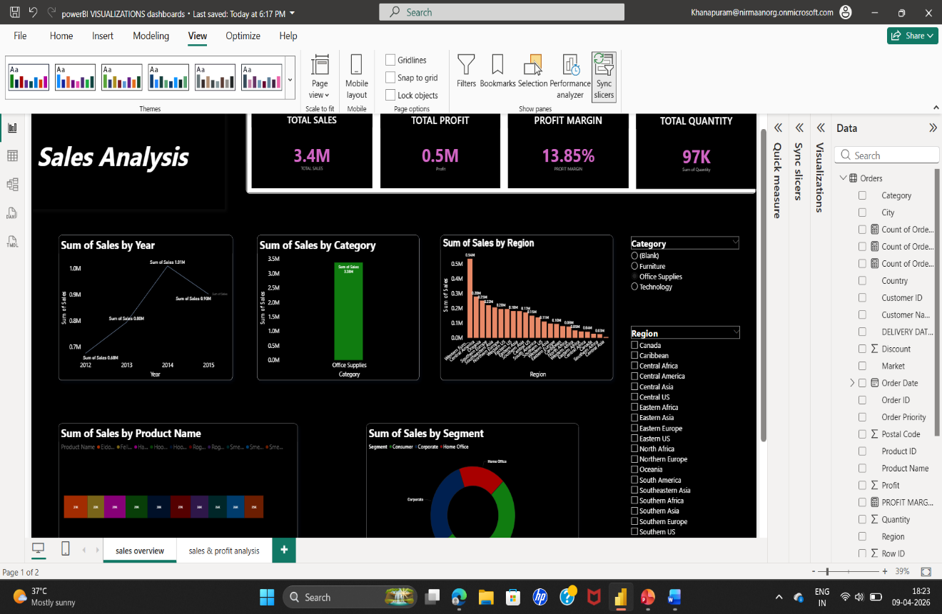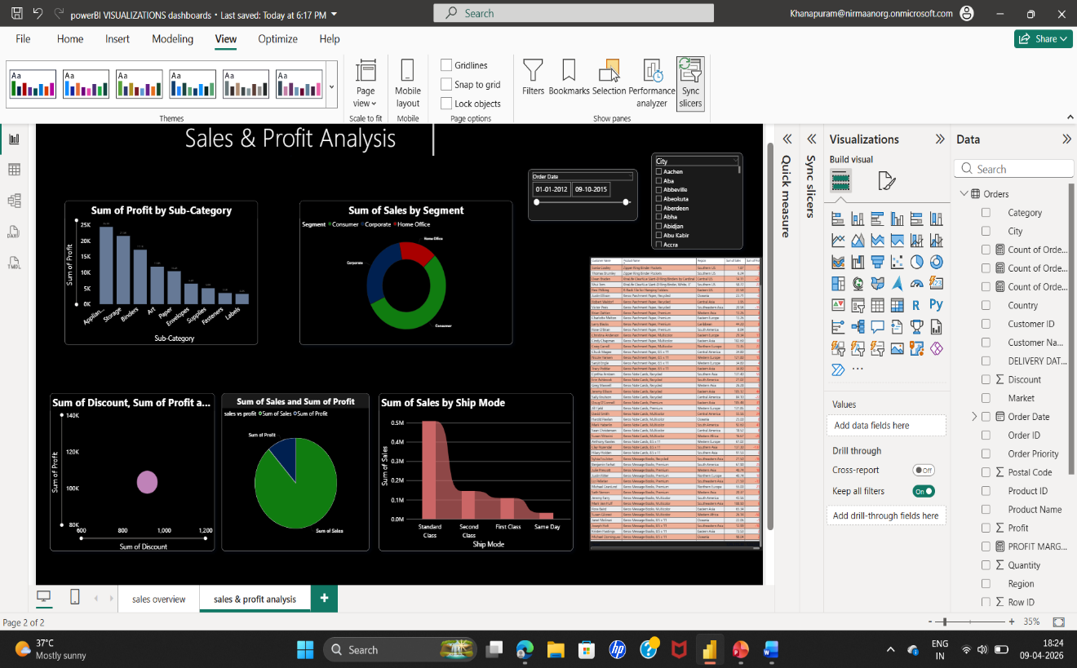

4.3 AI Tool Integration Results
- Tool used: Microsoft Copilot / ChatGPT.
- Prompts used: “Analyse the global superstire dataset and identify key sales and profit trends”
“generate insights and conclusions based on sales, profit and regional performance”
- Output quality: The AI-generated outputs were highly relevant, structured, and easy to understand. The tools provided clear insights, meaningful KPIs, and well-organized content for reports and dashboards. However, minor refinements were required to align the results with the dataset and project objectives.
- How it enhanced the project: Improved efficiency by reducing time spent on manual analysis and content writing
- Enhanced insight generation with intelligent suggestions and trend identification
- Supported dashboard design by recommending layouts and KPIs
- Assisted in report writing by generating conclusions, summaries, and documentation
- Enabled better decision-making through quick and data-driven insights

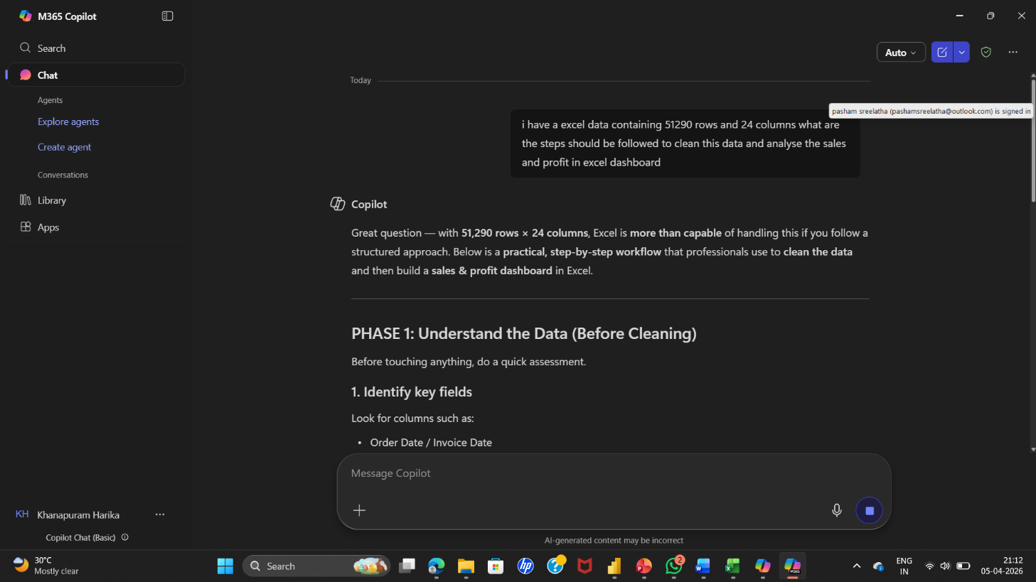

CHAPTER 5
Discussion and Conclusion
5.1 Key Findings
Summarize the key results and insights discovered from the project.
- Key Finding 1: After cleaning, 6% of the records were found to be duplicates — removing them significantly improved dashboard accuracy.
- Key Finding 2: The AI Copilot reduced the time needed to generate a summary report from 2 hours to under 10 minutes.
- Key Finding 3: The Technology category generated the highest profit, visible clearly in the Power BI dashboard.
- Key Finding 4 : the total profit is 1.5 million and profit margin is 11.61%,visible in the power BI dashboard KPI card.
5.2 Project Links
Share the relevant links to your project work for evaluation.
- GitHub Link of the Project: https://github.com/harikakanapuram2006-web/my-project.git

- Video Recording of Project Demonstration: https://drive.google.com/file/d/1hUMp1dkWJFgfmguXwI4L3ZDjptA9zXfP/view?usp=drivesdk

- Power BI / Dashboard Link : https://app.powerbi.com/reportEmbed?reportId=75f0f556-adc0-42d7-92d5-03f47ce8c215&autoAuth=true&ctid=aed43286-0f66-47d6-942b-d31a4b8addca
5.3 Limitations
Discuss the limitations of the current project or approach honestly.
- Limitation 1: The project was tested on a sample dataset and may not generalize to all real-world scenarios.
- Limitation 2: Microsoft Copilot access was limited during the project, which restricted some AI-assisted features.
- Limitation 3: The dashboard does not support real-time data refresh due to tool limitations.
- Limitation 4 : The analysis lacks customer-level insights.
5.4 Future Work

- Integrate real-time data pipelines using Power Automate or API connections.
- Apply machine learning models (e.g., forecasting, anomaly detection) on top of the cleaned dataset.
- Build a web-based interface or Power Apps solution for non-technical end users.
- Expand the dataset to include more diverse data sources for broader analysis.
- Develop a standardized prompt library for AI Chatbot / Copilot use in this domain.
- Create AI prompt library for reporting
5.5 Conclusion
Summarize the overall impact and contribution of the project.
This project addressed the challenge of understanding and analyzing a large retail dataset to extract meaningful business insights. Using tools like Microsoft Excel and Power BI, the dataset was cleaned, transformed, and visualized to identify key trends in sales, profit, customer segments, and regional performance.
Through this analysis, important insights were discovered, such as high-performing regions, loss-making products, and sales patterns across different categories. The interactive dashboards created enable easy exploration of data, helping stakeholders make informed and data-driven decisions.
All the project objectives were successfully achieved, including data cleaning, analysis, visualization, and dashboard creation. This project adds value by demonstrating how raw business data can be converted into actionable insights for improving profitability and operational efficiency.
Overall, this experience enhanced practical knowledge in data analytics, dashboard design, and storytelling with data. It also provided hands-on exposure to real-world tools and techniques, improving skills in problem-solving and AI-assisted reporting.

REFERENCES

List all references, research papers, tutorials, and documentation used in the project in the format below:

[1] Microsoft Corporation. Microsoft Excel Documentation. Available at: https://support.microsoft.com/en-us/excel
[2] Microsoft Corporation. Power BI Documentation. Available at: https://learn.microsoft.com/en-us/power-bi/
[3] Microsoft Corporation. Microsoft Copilot — AI-Powered Productivity. Available at: https://copilot.microsoft.com
[4] Edunet Foundation. AICW Fellowship Program Guidelines. 2026.

APPENDICES

Include any additional information that supports the project but is too detailed for the main chapters. This may include:

Appendix A — Sample Dataset
Row ID | Order ID | Order Date | Ship Date | Ship Mode
40098 | CA-2014-AB10015140-41954 | 11-11-2014 | 13-11-2014 | First Class
26341 | IN-2014-JR162107-41675 | 05-02-2014 | 07-02-2014 | Second Class
25330 | IN-2014-CR127307-41929 | 17-10-2014 | 18-10-2014 | First Class
13524 | ES-2014-KM1637548-41667 | 28-01-2014 | 30-01-2014 | First Class
47221 | SG-2014-RH9495111-41948 | 05-11-2014 | 06-11-2014 | Same Day
22732 | IN-2014-JM156557-41818 | 28-06-2014 | 01-07-2014 | Second Class
30570 | IN-2012-TS2134092-41219 | 06-11-2012 | 08-11-2012 | First Class
31192 | IN-2013-MB1808592-41378 | 14-04-2013 | 18-04-2013 | Standard Class
40099 | CA-2014-AB10015140-41954 | 11-11-2014 | 13-11-2014 | First Class

Appendix B — Key Excel Formulas / DAX Measures Used
- =IFERROR(VLOOKUP(...), "Not Found") — used for data validation
- =COUNTIF(range, criteria) — used to count duplicates
- Power BI DAX: Total Sales = SUM(Sales[Revenue]) — used in dashboard KPI card
- Profit margin=total sales/total profit— used in power BI to calculate profit margin KPI card
Appendix C — AI Prompts Used

- Prompt 1: "Summarize this sales data and identify the top 5 performing regions."
- Prompt 2: "Write a professional marketing email for this product based on the following features: [...]"
- Prompt 3: "Identify any anomalies or outliers in this dataset and explain their possible causes”
Appendix D — Screenshot Gallery
